**Spark**

**Q-2.1**

df.agg((min("avg_rev_per_seat").alias("min_rev")),(max("avg_rev_per_seat").alias("max_rev")),(avg("avg_rev_per_seat").alias("avg_rev"))).show()

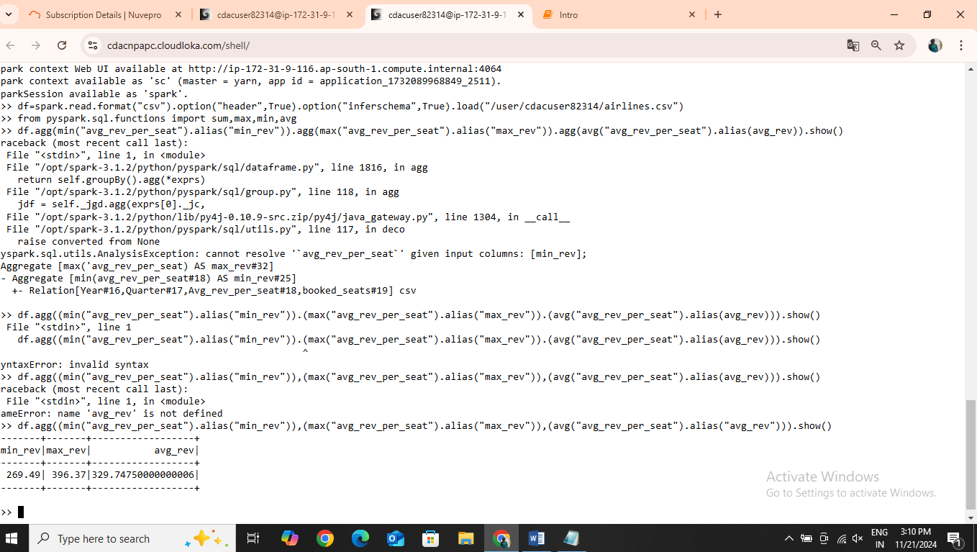

**Q-2.3**

df.groupby("year").agg(sum("booked_seats").alias("total_seats")).orderBy("total_seats",ascending=True).show()

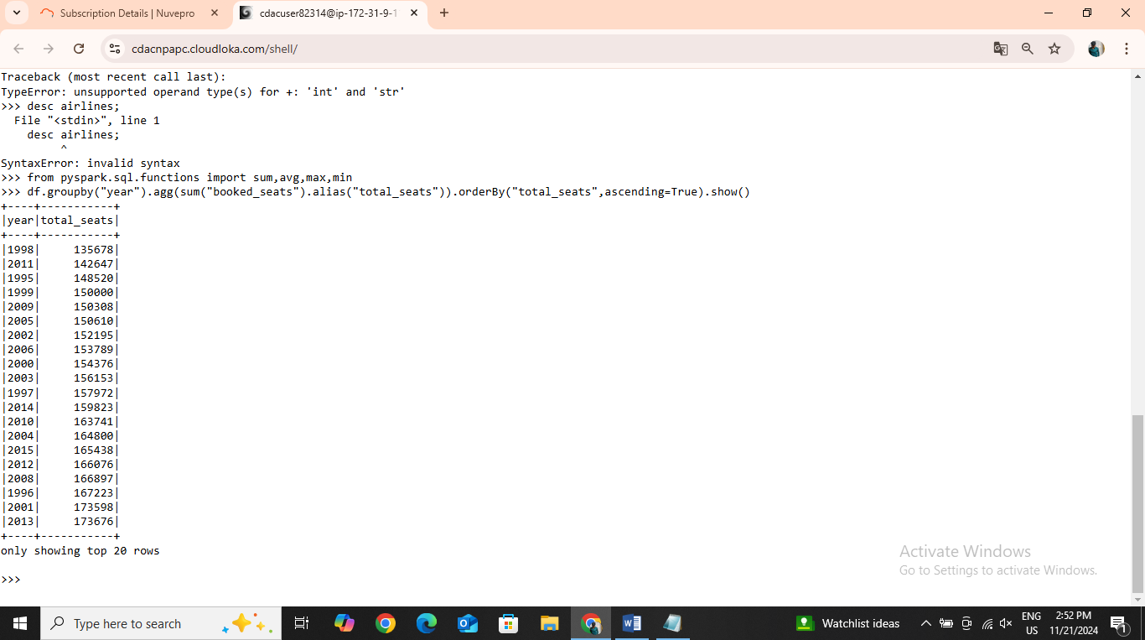

**Q-2.4**

df.groupby("year").agg(sum("booked_seats").alias("total_seats")).orderBy("total_seats",ascending=True).show()

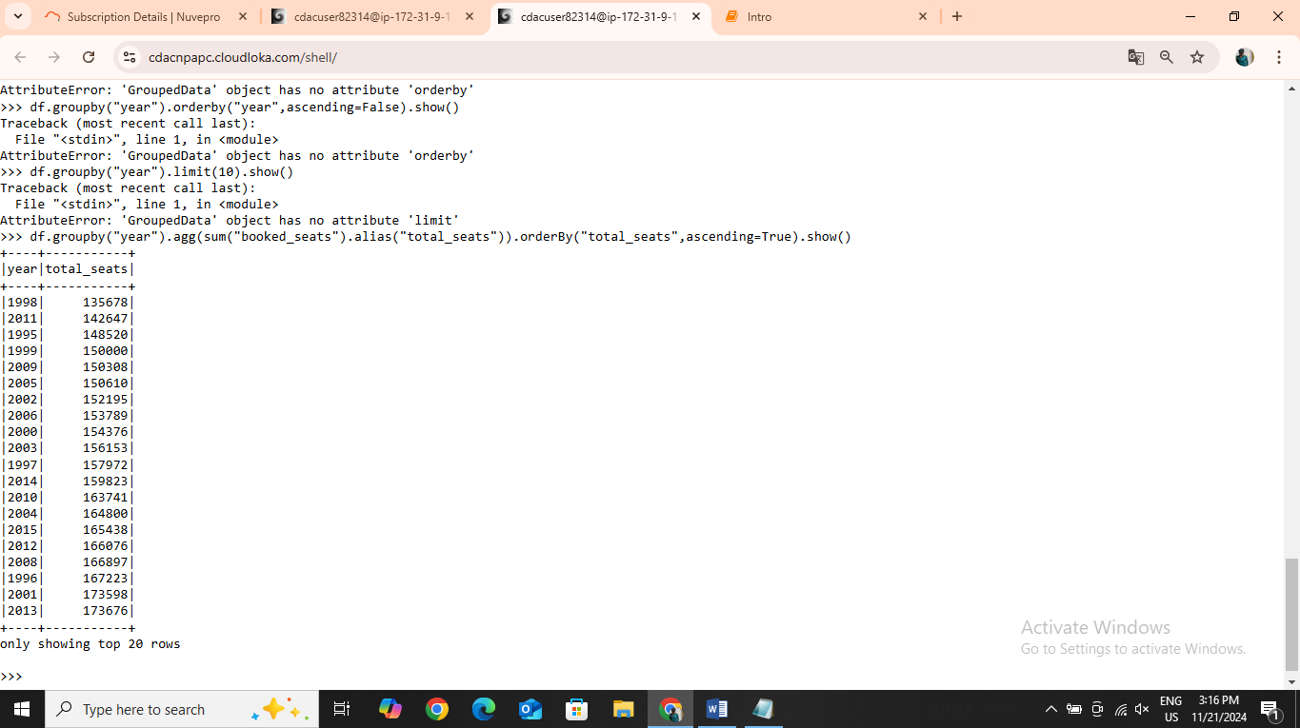

**Q-2.5**

df.groupby("year").agg(sum("avg_rev_per_seat").alias("total_rev")).orderBy("total_rev",ascending=True).show()

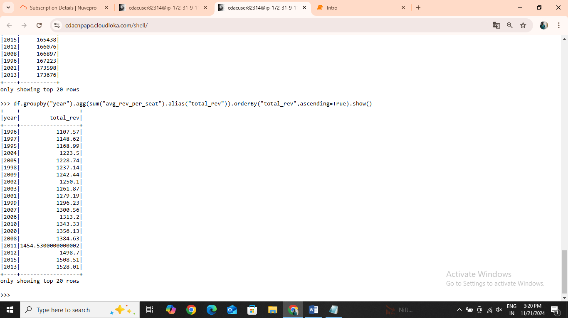

**Hive :**

**Q-1.1**

select distinct(name) from airport as a

join routes as r

on a.airport_id=r.src_airport_id

join routes as rr

on a.airport_id =rr.dest_aiport_id

limit 10 ;

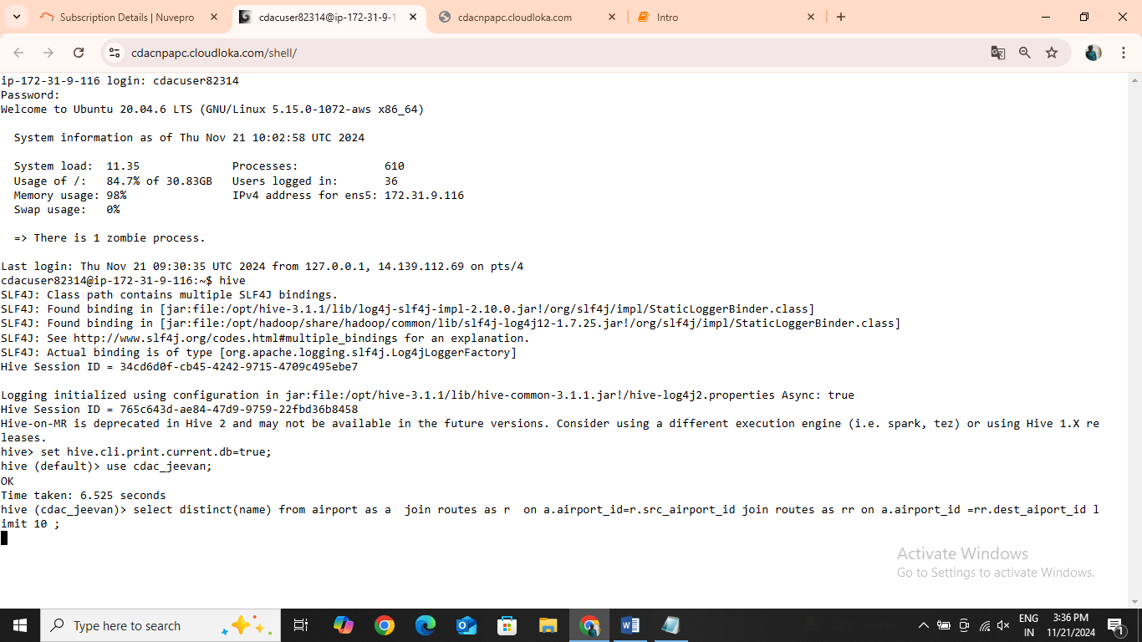

**Q2.1**

create table routes_partition (airline_iata string , airline_id int , src_airport_iata string , src_airport_id int , dest_airport_iata string , dest_airport_id

int , codeshare string , stop int , equipment string ) partitioned by(src_airport_id) row format delimited fields terminated by "," stored as textfile;